BIT 4107 – MOBILE APPLICATION DEVELOPMENT
ENHANCED PROFESSIONAL STUDENT LOGBOOK
Student Name: MODECAY SENDWAH
Admission Number: BIT/2024/54918
School/Faculty: COMPUTING AND INFORMATICS
Programme: MOBILE APPLICATION DEVELOPMENT
Academic Year: 2025/2026
Semester: 3.2
Lecturer: MR NYORO MICHAEL
Phone Number: 0796034089
WEEK 1: INTRODUCTION TO MOBILE APPLICATION DEVELOPMENT
Practical Activities Undertaken
• Studied the concept of mobile application development.
• Learnt the importance and applications of mobile applications.
• Explored Android and iOS mobile platforms.
• Installed Flutter SDK and related development tools.
• Created a simple Flutter project.
• Examined the Flutter project structure and widget architecture.
Screenshots/Evidence Attached
Tools/Software Used
• Flutter SDK
• Visual Studio Code
• Android Studio
• Git
• Windows Operating System
Personal Reflection
I gained foundational knowledge of mobile application development and became familiar with Flutter. This week provided the necessary background for developing mobile applications throughout the course.
WEEK 2: MOBILE DEVELOPMENT ENVIRONMENT
Practical Activities Undertaken
• Configured Flutter environment variables.
• Installed Android Studio and Android SDK.
• Installed required SDK components.
• Created and configured Android Virtual Devices (AVDs).
• Verified installation using Flutter Doctor.
• Successfully ran Flutter applications on an emulator.
Screenshots/Evidence Attached
Yes
Tools/Software Used
• Flutter SDK
• Android Studio
• Android Emulator
• Visual Studio Code
• Git
Personal Reflection
I successfully configured the mobile development environment and learned how to run applications on Android emulators. This improved my troubleshooting and software configuration skills.
WEEK 3: USER INTERFACE DESIGN
Practical Activities Undertaken
• Designed user interfaces using Flutter widgets.
• Developed Login Screen.
• Developed Registration Screen.
• Developed Dashboard Screen.
• Developed Profile Screen.
• Implemented navigation between application screens.
• Applied layouts using Scaffold, Column, Row, and Container widgets.
• Customized themes and application appearance.
Screenshots/Evidence Attached
Yes
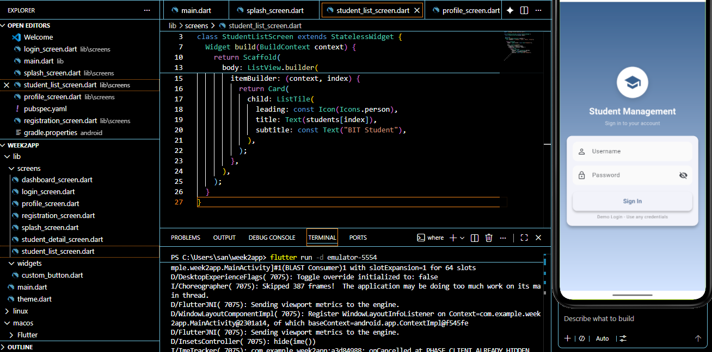
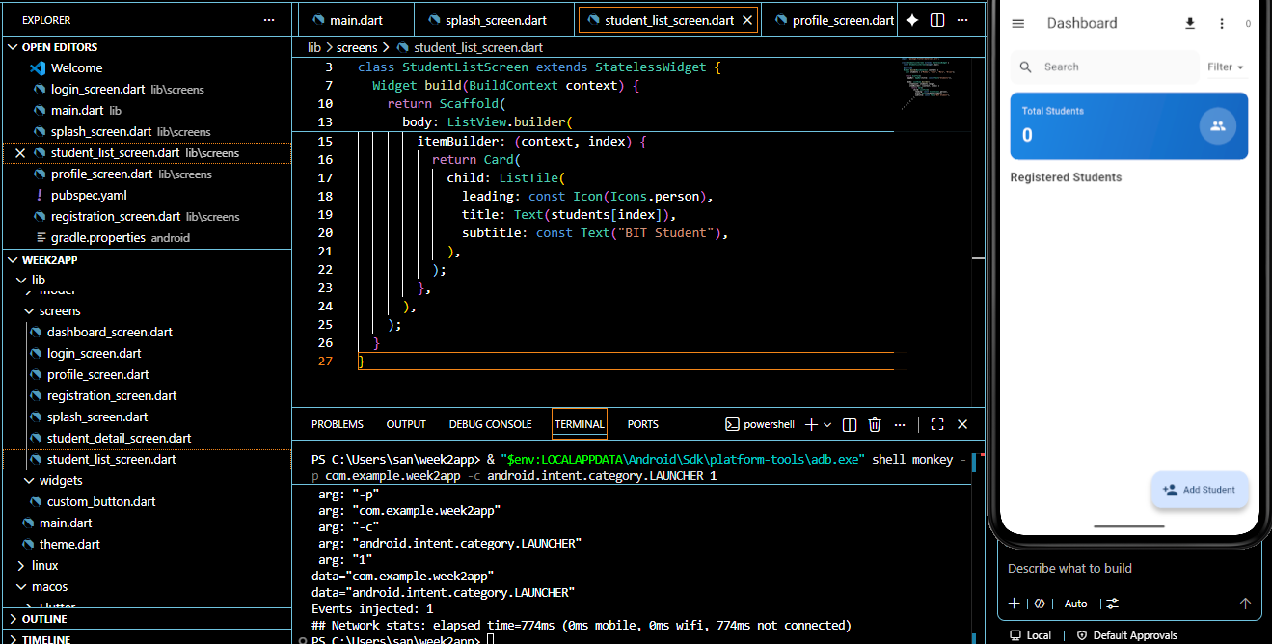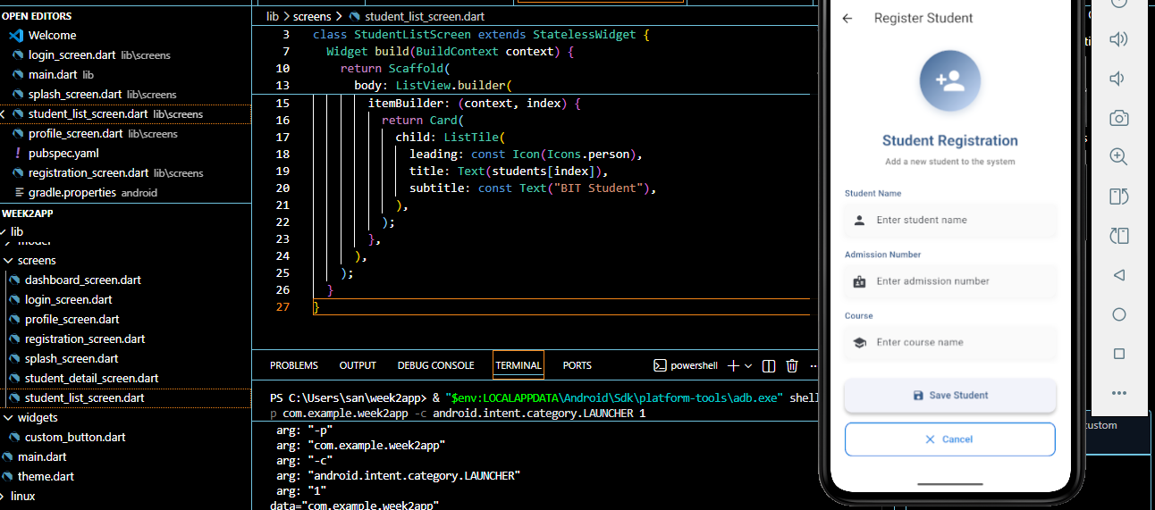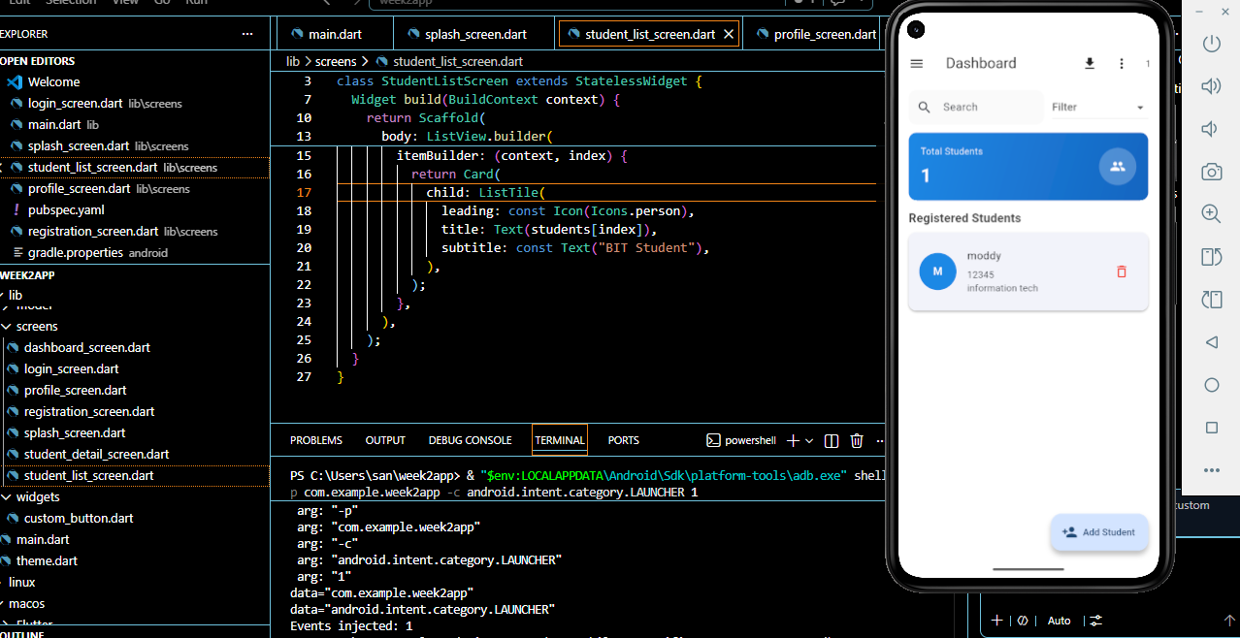
Tools/Software Used
• Flutter SDK
• Visual Studio Code
• Android Emulator
Personal Reflection
I learned how to design responsive user interfaces using Flutter widgets. The activities improved my understanding of application navigation and user experience design.

WEEK 4: EVENT HANDLING AND USER INTERACTION
Practical Activities Undertaken
• Created a new Flutter application named RecordHub.
• Implemented user interaction using buttons and form controls.
• Developed Add Record functionality.
• Created Record List screen for displaying records.
• Implemented navigation between screens.
• Developed Edit Record functionality.
• Implemented Delete Record functionality.
• Added form validation for user input.
• Tested user interaction and application flow.
Screenshots/Evidence Attached
Yes
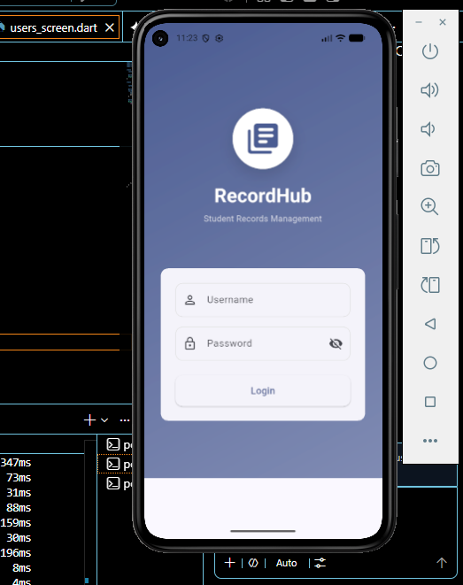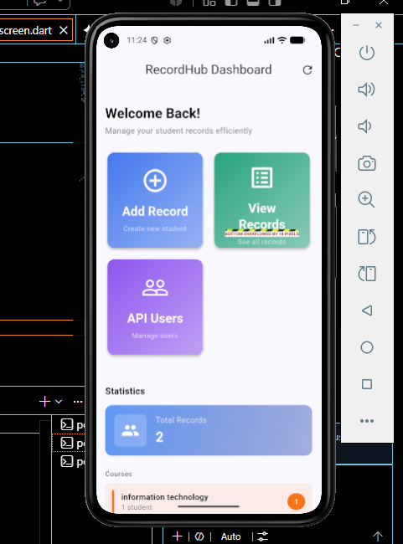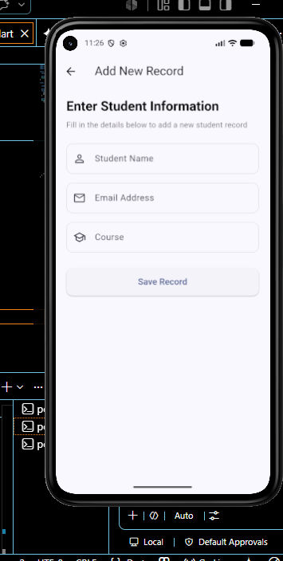.

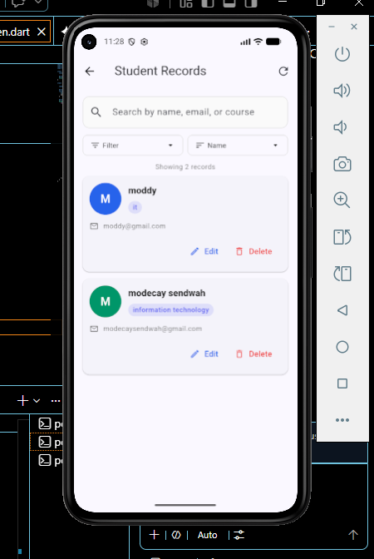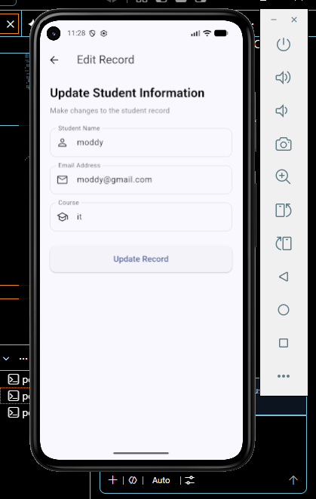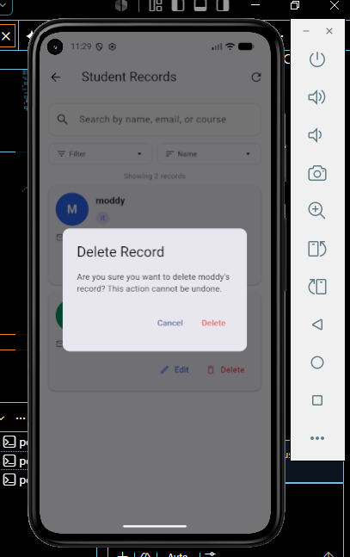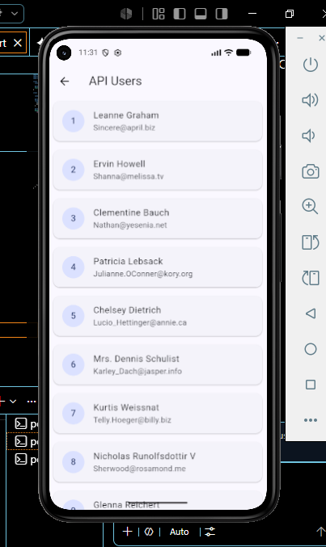
Tools/Software Used
• Flutter SDK
• Visual Studio Code
• Android Emulator
• Dart Programming Language
Personal Reflection
I learned how to handle user interactions and events within a Flutter application. Implementing navigation, validation, editing, and deletion improved my understanding of application functionality and user experience.
WEEK 5: DATA MANAGEMENT
Practical Activities Undertaken
• Implemented local data storage using SQLite.
• Created a database helper class.
• Designed a Record model for storing information.
• Implemented CRUD operations:
- Create Records
- Read Records
- Update Records
- Delete Records
• Retrieved and displayed stored records.
• Implemented search functionality.
• Integrated API consumption concepts.
• Retrieved external data from a public API.
• Displayed API records within the application.
• Tested database and networking functionality.
Screenshots/Evidence Attached
Yes

Tools/Software Used
• Flutter SDK
• SQLite Database
• HTTP Package
• Visual Studio Code
• Android Emulator
• Dart Programming Language

Personal Reflection
I gained practical experience in managing application data using SQLite and integrating external APIs. The implementation of CRUD operations and API consumption enhanced my understanding of data persistence and mobile application networking.

